Add cover Add comment

**Orderblocks**

**n r** • **0 d r** **ry**

[Selecting & Avoiding]

Bullish Orderblock:

**Definition** - The Lowest Candle or Price Bar with a Down Close that has the most range between Open to Close and is near a "Support" level.

**Validation:** When the High of the Lowest Down Close Candle or Price Bar is traded through by a later formed Candle or Price Bar.

**Entry Techniques:** When Price trades Higher away from the Bullish Orderblock and then Returns to the Bullish Orderblock Candle or Price Bar High - This is Bullish.

**Defining Risk:** The Low of the Bullish Orderblock is the location of a relatively safe Stop Loss placement.

Just below the 50% of the Orderblock total range is also considered to be a good location to raise the Stop Loss after Price runs away from the Bullish Orderblock to reduce Risk when applicable.

When people with a lot of money in the market get involved youll notice it in price action When we get a down candle we can be assuming we get a orderblock

**Reinforcing Orderblock Th ory**

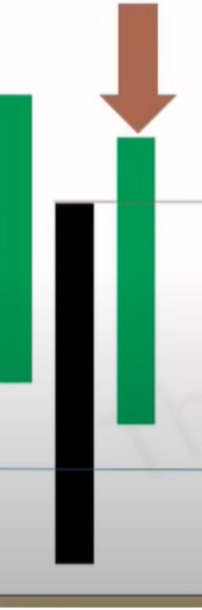

Validated Orderblock

Support Level

(5 lect ng & **Avo** d1 •

**Bullish Orderblock:**

**Definition** - The Lowest Candle or Price Bar with a Down Close that has the most range between Open lo Close and is near a "Support" level.

**Validation:** When the High of the Lowest Down Close Candle or Price Bar is traded through by a later formed Candle or Price Bar.

**Entry Techniques:** When Price trades Higher away from the Bullish Orderblock and then Returns to the Bullish Orderblock Candle or Price Bar High - This is Bullish.

Defining **Risk:** The Low of the Bullish Orderblock is the location of a relatively safe Stop Loss placement.

Just below the 50% of the Orderblock total range is also considered to be a good location to raise the Stop Loss after Price runs away from the Bullish Orderblock to reduce Risk when applicable.

Even in the candle that broke the high, if it trades back immediately we can enter on the same candle that broke the high, if you didnt enter yet, we will be waiting on a retracement after the displacement



Primarily we focus on the body of the candles, so we wenter on the high of the body, if we use wicks we're overlapping orderblocks with FVGs thats when ICT uses the wicks

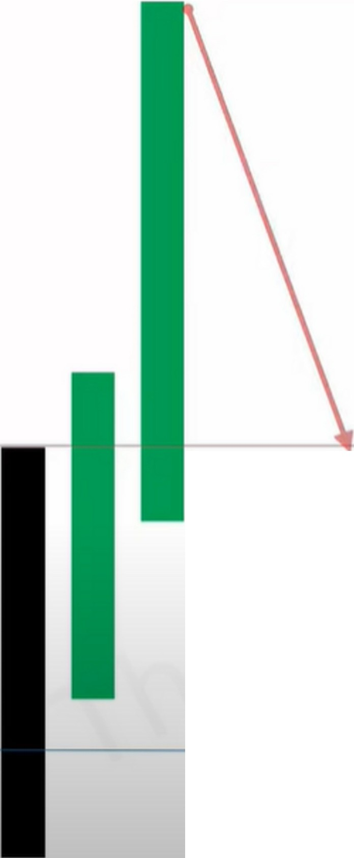

**Support Level**

Set an alert at the orderblock and wait, the hardest part is waiting, but you should have your risk ready and your target



This is where you enter



**Support Level**

If its a limit order, add some pips for spread because youre buying



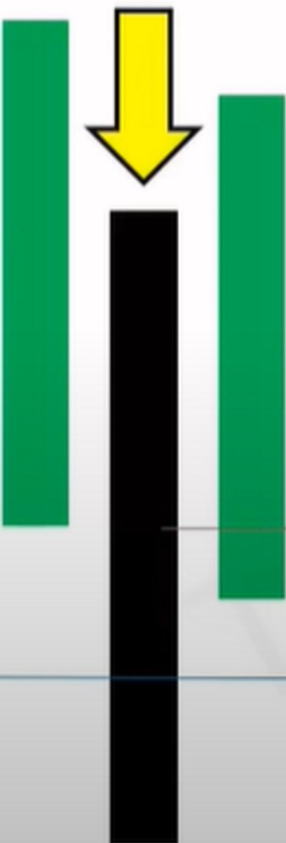

Buy Stops

Buy Level

Mean Threshold



The best orderblocks will not trade below the 50% of the orderblock, 50% measured from the body open to close, the mean threshold

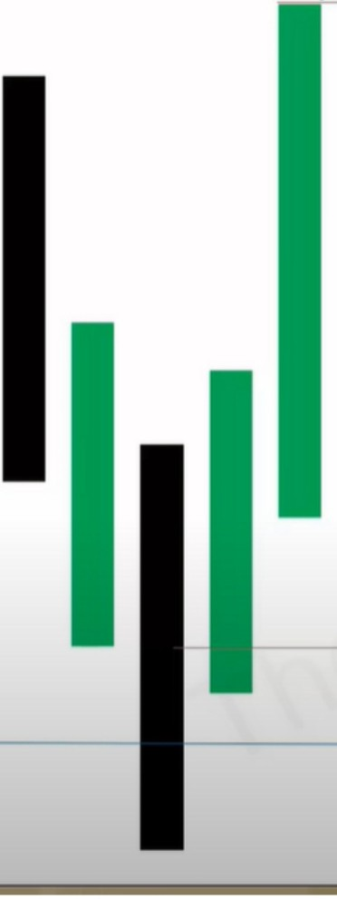

**External Range Liquidity**

I

**Internal Range Liquidity**

**Support Level**

**Buy Stops**

I

**Buy Level**

Stop loss could be below the low of the wick but primarily we will place stop loss below the body of the candle





**Pair Long Exit With Buy Stops**

**Support Level**

There will be sub topics in december about orderblocks as well

|  |  |  |
| --- | --- | --- |
|  |  | **d Bias**  Monthly Chart = Bearish Weekly Chart= Bearish Daily Chart = Bearish |
| **Weekly** | lntraday Charts 4 hour and less will be correcting or retracing higher. This is where you anticipate the market to enter a Premium and seek Buy Side Liquidity to  Sell to. |
| Bearish |  |
| **Daily** | Protective Buy Stop Raids or Returns to  Bearish Orderblocks or fair Value Gaps and or filling of a Liquidity Void. Each offering a potential Low Resistance Liquidity Run - Shorting for a target under  a recent Low. |
| Bearish |  |

Primarily we're going to be trading in the direction of the monhtly chart

the Daily can switch more between bullish and bearish while the monthly will continue the bearish bias

|  |  |  |  |  |
| --- | --- | --- | --- | --- |
|  |  |  |  | **d Bias**  Monthly Chart = Bullish Weekly Chart= Bullish Daily Chart= Bullish |
| **Weekly** | lntraday Charts 4 hour and less will be correcting or retracing lower. This is where you anticipate the market to enter a Discount and seek Sell Side Liquidity to Buy  from. |
| Bullish |  |
| **Daily** | Protective Sell Stop Raids or Returns to  Bullish Orderblocks or Fair Value Gaps and or filling of a Liquidity Void. Each offering a potential Low Resistance Liquidity Run - Buying for a target above a recent High. |
| Bullish |  |

Weekly and monthly charts are higher odds if you have a clear target

Orderblocks are formed at support levels

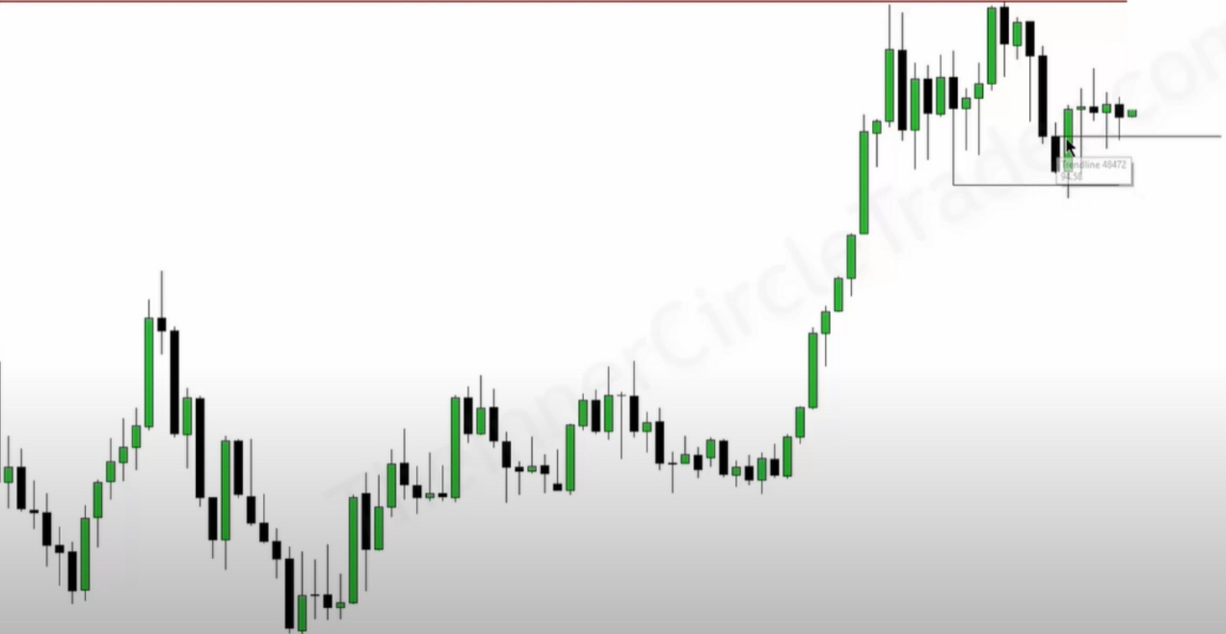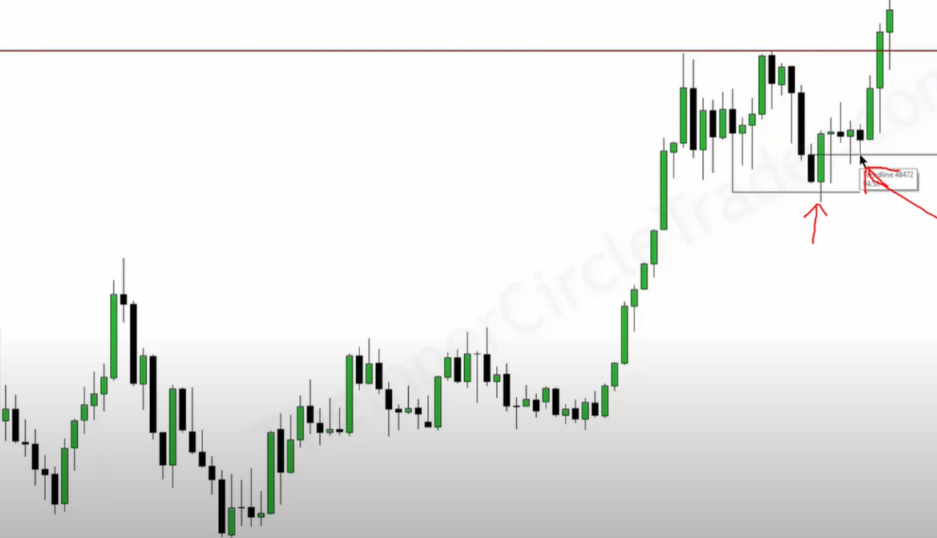

Theyre pushing price down to buy at a cheaper price

* Ul0k. ,IIUJIILA1a111N.11

-

i-ii

tt

_,..,

--

-

11'

...

~

j111

t1

-

.,,.,

"'

lj!iJ

1111111

'I

I 11111,,1 il

...

..-.

111111

'

1

.~..

'

,,

I

'"

w

'"

"'

A refined OB to the weekly that reacted off of the monthly OB

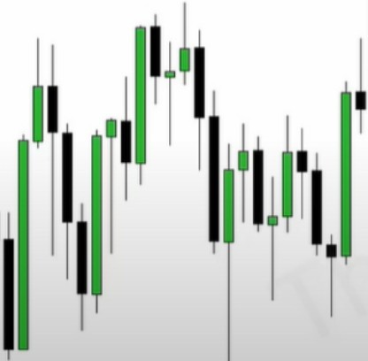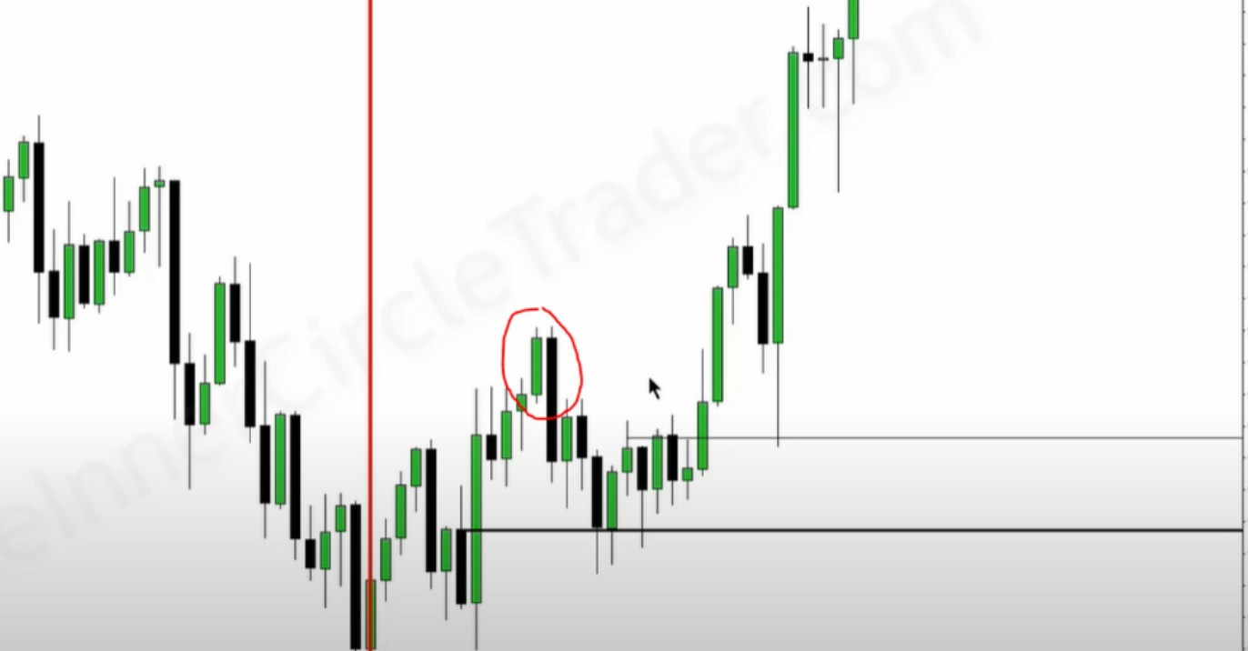

This bearish orderblock will not be considered, because the HTF is suggesting were going higher Bullish, so buy on dips and sell on rallies

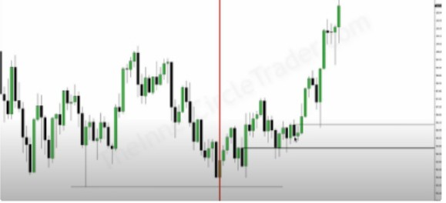ICT wants to see 2/3 rallies away, so 2/3 the size of the orderblock and then wait for a retracement thats when it can still come down, so it isnt "mitigated" if it already touched the OB when it just made it, it usually retraces to the OB once more when we rally 2/3 the size of the OB away. And when the refined bullish orderblock's open is higher then the original one, and of course it needs to react off of a support level thats when we can refine it, so all the criteria again, so in the examples below we have 3 orderblocks close to eachother in a row

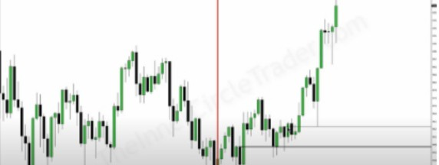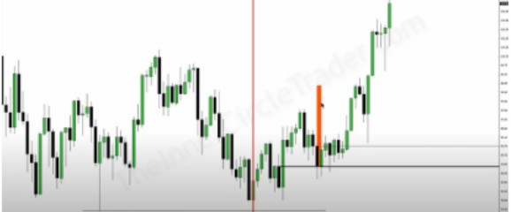

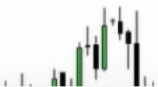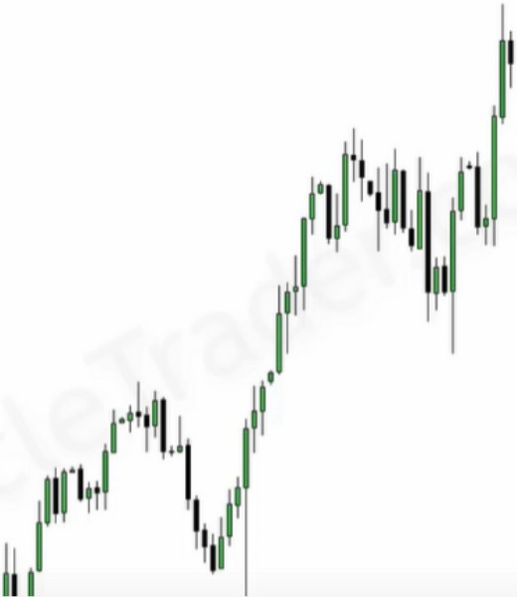If theres 2 downcandles in a row or more, then thats 1 full orderblock

Here we had a run on stops, so ICT said that he didnt expect price to come all the way down to the refined OB because of the run on stops it had so it wasnt nescesarry. So he used the bigger OB and used the mean threshold

Wait for displacement and then simply wait for these levels to be traded back into

You can refine them to even the 5m TF if you want, but only focus on the direction of the monthly weekly and daily TF and those orderblocks are the ones you want to buy

Bearish orderblocks can be a good profit taking target, if you hit it for example during a time profit taking should take place so london close, then close at the bearish orderblock and wait for the next day to retrace and then we will take out the high. Only focus on bearish orderblocks when time of day is an impact, if time of day isnt then dont even conside the bearish orderblock and expect it to be traded trough, they could pause and consolidate there for a little bit. Because the big boys dont want to take profit AT an old high they want to take profit above it and take out other people with their SL there

Only focus on bullish orderblocks when the monthly weekly and daily support it